PWM 8BIT 500HZ
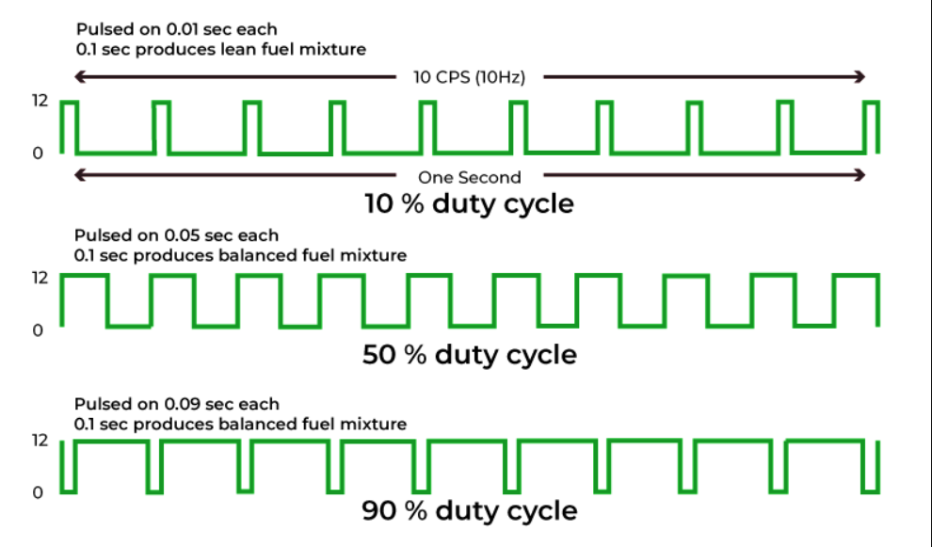

Professor: Dr. Miguel Angel Rivera Acosta

Students:
Alonso Emmanuel López Macias
Cesar Eduardo Inda Ceniceros.
Luis Alberto Castañeda Montaño
José Antonio Garcia Madrigal

  - Team:9

Date: June 20th, 2025

THEORICAL FRAMEWORK

1.- INTRODUCTION
The objective of this project is to design and simulate an 8-bit PWM (Pulse Width Modulation) signal generator using the System Verilog hardware description language and the Vivado development tool. The design is carried out at the RTL (Register Transfer Level), without the need to implement the circuit on a physical FPGA, focusing solely on its functional modeling and verification through simulation

2.- DEFINITION
PWM (Pulse Width Modulation) is a technique used to generate digital signals with a periodic waveform, where the duty cycle of the signal is controlled. The duty cycle defines the proportion of time the signal remains at a high level ('1') relative to the total period. Common applications of PWM include:
- Speed control of DC motors
- Brightness regulation of LEDs
- Generation of analog signals through filtering
- Data communication in certain protocols

A PWM signal does not change its frequency but varies its pulse width to represent different levels of power or intensity.

3.- FUNDAMENTALS
The PWM generator to be developed in this project is defined with the following characteristics:
- Resolution: 8 bits (256 possible duty cycle levels).
- Frequency: 500 Hz.
- Control input: an 8-bit value that defines the duty cycle.

To generate the PWM signal, a counter is used that increments from 0 to 255 periodically. The duty cycle value is compared with the counter value in each cycle. If the counter is less than the duty cycle value, the PWM output will be high; otherwise, it will be low. Example: if the control value is 128, the duty cycle will be 50% (128/255). The general formula for calculating the duty cycle is:
$$DutyCycle \left(\%\right)=\frac{Control Value}{255}x 100$$
Equation 1 Pwm DutyCycle

To generate a 500 Hz signal with 256 steps per period, each step must occur every:
$$\frac{1}{\frac{500}{256}}=7.8125 μs$$
Equation 2 256Steps --> 500 Hz

The consideration for PWM Period is:
$$TPWM=\frac{1}{fPWM}=\frac{1}{500HZ}=2ms$$
Equation 3 PWM Period
The consideration for Hardware Clock Division is:
$$fCLK=50MHz, N=256, fPWM=500Hz$$
$$Cycles By Pass=\frac{\frac{fCLK}{fPWM}}{N}=781 Cycles$$
Equation 4 Cycle By Pass FPGA
These equations represent the conditions for any consideration in the times or frequency requeriments.

ESPECIFICATIONS

4.- RTL
The RTL-level design involves describing the system’s behavior using sequential and combinational elements:
- Counter: a sequential component that increments on each clock cycle.
- Comparator: combinational logic that compares the counter value with the desired duty cycle.
- PWM Output: result of the comparison (high or low level).

This design allows precise control over the signal’s duty cycle, leveraging the 8-bit resolution to achieve 256 possible modulation levels.
Pseudocode representation:
if (counter < duty_cycle)
pwm_out = 1;
else
pwm_out = 0;

PWM GENERATOR
CLK
COUNTER

0-255(8 Bits)
COUNTER < DUTY CYCLE

PWM = 1 if
Counter < duty cycle)
PWM OUTPUT

Figure: 1 PWM Function Diagram

PWM waveform representation in 16 units a brief for 256. Each bit represents a step by the counter output is “1” if counter condition is “counter < duty cycle”
Duty | 0 | 0% | 0000000000000000
Duty | 4 | 25% | 1111000000000000
Duty | 8 | 50% | 1111111100000000
Duty | 12 | 75% | 1111111111110000
Duty | 16 | 100% | 1111111111111111

5.- GENERAL DESCRIPTION
The system consists of a PWM signal generator with:
- 8-bit resolution (256 duty cycle levels).
- Fixed output frequency: 500 Hz.
- Developed in System Verilog, simulated in Vivado.

An 8-bit counter is implemented, which counts from 0 to 255 and is compared against an input value called duty_cycle. If the counter is less than duty_cycle, the output pwm_out remains high (1); otherwise, it goes low (0).
8-bit Counter: Counts from 0 to 255. Resets to 0 when it reaches the maximum. Increments on each clock cycle.
Comparator (counter < duty_cycle): Compares the counter value against the duty_cycle. If the condition is true, pwm_out = 1; otherwise, pwm_out = 0.
Control Logic: The reset forces the counter to zero. The duty_cycle value can change dynamically.
Operation Sequence: At the start, cnt = 0 (active reset). On each clock edge:
- If reset_n == 0, cnt = 0.
- If reset_n == 1, cnt = cnt + 1 (with wrap-around).

The pwm_out output changes each cycle according to cnt < duty_in. The complete PWM cycle spans 256 clock cycles → 500 Hz.

6.- PINOUT
Signal | Direction | Width | Description
Clk | In | 1 | System Clock (50 MHz)
Reset | In | 1 | Asynchronous active-low reset
duty [8..0] | In | 8 | Duty cycle value (0-255)
Pwm out | out | 1 | PWM Output

7.- DECISION & JUSTIFICATION
8-bit Counter | Provides 256 resolution levels (0–255).  Compact memory and simple combinational logic.  Matches the 256 possible PWM levels (8-bit resolution).
Comparator | Generates the signal directly without additional logic, minimizing delay.  Minimizes additional logic and reduces RTL complexity.
Synchronous output with clk. | Simulation allows assuming a single cycle per increment.  Ensures stability in simulation and precise control.
Asynchronous reset (reset_n). | Ensures a defined initial state: cnt = 0, pwm_out = 0.  Facilitates deterministic behavior in simulation.

8.- CODE

